
Business To Manufacturing
Markup Language
Batch Markup Language
Version 0401 – October 2008
Release Notes



IMPORTANT: While the information, data, and standards provided in this publication were developed and are presented in good faith in accordance with a reasonable process that was subject to intellectual property and antitrust policies to benefit the industry as a whole, the publication is provided “as is” for information and guidance only, and there is no representation or warranty of any type or kind, including but not limited to warranties of merchantability or fitness for a particular purpose, and no warranty that use of the information, data, or standards will not infringe patent, copyright, trademark, trade secret, or other intellectual property rights of any party.

The changes from B2MML V04 are:

- Separate the Core Components into a separate schema file. This allows the Core Component schema file to be used in other custom schemas
- Separated the extension file into two, one for the B2MML elements and one for the Common elements. This allows the common elements to be used in other custom schemas.
- In Production Performance schema: Added maxOccurs to resources in Segment Responses.
- In Production Schedule schema: Changed maxOccurs for resource elements in Segment Requirements.
- Use of a single namespace ‘namespace=http://www.wbf.org/xml/B2MML-V0401d05-Extensions’ that would be used for all extension files.
- Added “EquipmentModule” and “ControlModule” to EquipmentElementType to allow use of the same type in BatchML.
- Fixed the type of MaterialActual in the Production Schedule schema
- Changed the type name for OtherInformation in the General Recipe Schema because of a name conflict when changing the include structure.
- Added nillable=”true” to selected elements in B2MML-Common. This is a minimal change for those elements that have minOccurs=1, but could be NULL. This is the value string, datatype (if the string in NULL, then the datatype is NULL), and UnitOfMeasure. The changes were made in QualityValueType, ResultType, and ValueType.
- Changed the include and import structure to the following:
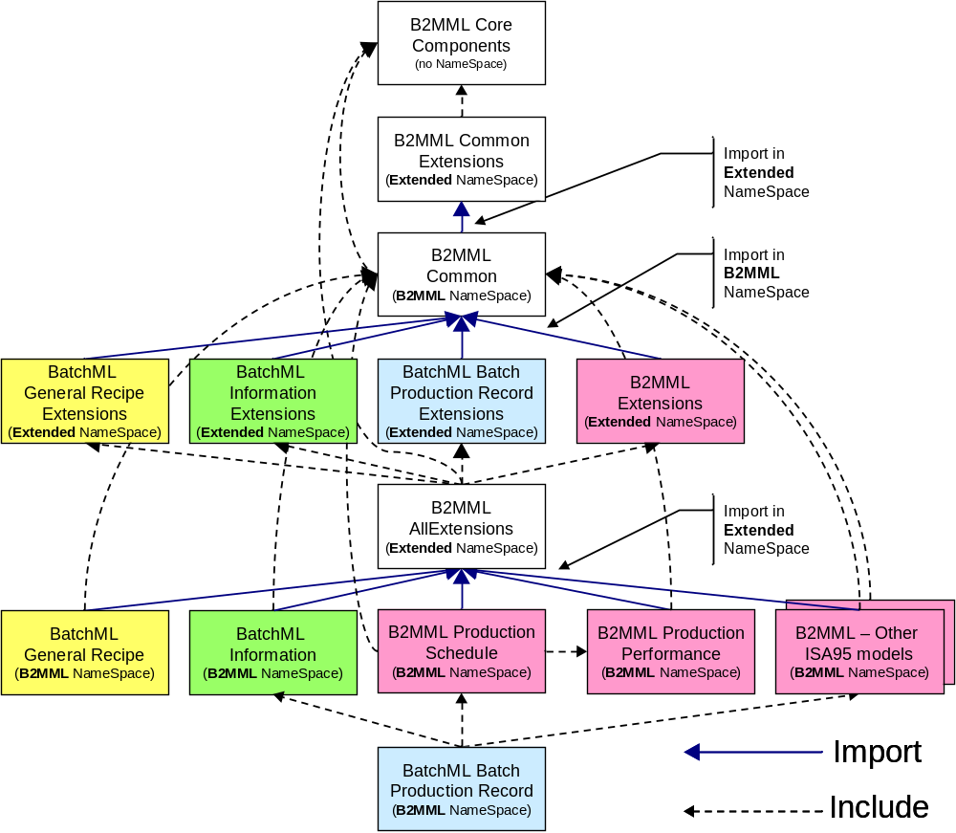

- Addition of BatchML to the B2MML numbering scheme.
- Change of the filename from BatchML-Vxxxx.xsd to BatchML-Vxxxx-BatchInformation.xsd. This follows the B2MML file name convention and will be consistent with Batch Production Records, and General Recipe BatchML schemas.
- Changes to BatchML to make it work in the B2MML namespace and use the B2MML Common, Common extensions, and core component types. These changes include:
  - Changes of all SimpleTypes to ComplexType with a restriction base of a core component type
  - Removed the following types because they were already in B2MML Common.
ActualEndTimeType, ActualStartTimeType, AnyType, DataType1Type, DataTypeType, TextType, EquipmentElementType, UnitOfMeasureType, ValueStringType, VersionType
- Added extension elements to:
ApprovalHistoryType, BatchInformationType, BatchListEntryType, BatchList, BatchSizeType, ClassInstanceAssociationType, Constraint, ControlRecipe, EnumerationSetType, Enumeration, EquipmentConnection, BatchEquipmentIDType, EquipmentProceduralElementClass, EquipmentProceduralElementType, BatchEquipmentRequirementType, FormulaType, FromIDType, HeaderType, IndividualApproval, LinkType, ListHeaderType, MasterRecipeType, ModificationLogType, OtherInformationType, BatchParameterType, ProcedureLogicType, EquipmentElementPropertyType, RecipeBuildingBlock, RecipeElementType, StepType, ToIDType, TransitionType, BatchValueType,
- Added BatchML-BatchInformationExtensions schema.
- Change the name of elements to eliminate conflict with B2MML Common types:
EquipmentIDType to BatchEquipmentIDType
EquipmentRequirementType to BatchEquipmentRequirementType
ParameterType to BatchParameterType
PropertyType to EquipmentElementPropertyType
ValueType to BatchValueType
- Addition of BatchML-GeneralRecipe schema
- Addition of BatchML-GeneralRecipeExtensions schema.

